DARS/u.select Users Conference - another big turnout!

90 participants attended this year’s conference held at the Crowne Plaza in Brooklyn Center on October 2 - 3, 2012.

This year’s sessions included: u.achieve Update, Tips & Tricks, eCatalog Creation, Legacy Planning, Discipline Changes including a panel discussion, a CollegeSource Conference session, u.select Update & Promotion, as well as breakout sessions on exceptions, transfer issues, condition codes, and u.select training. Participants also attended the “Town Hall Meeting” for open discussion.

In celebration of our 10th conference, DARS & u.select memorabilia was displayed and a special 10th Anniversary cake was served. “We’ve Come A Long Way!”

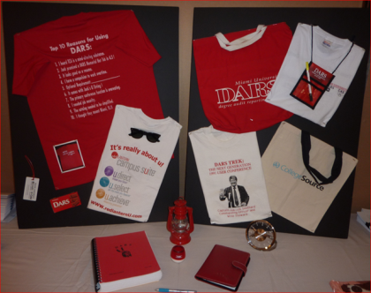
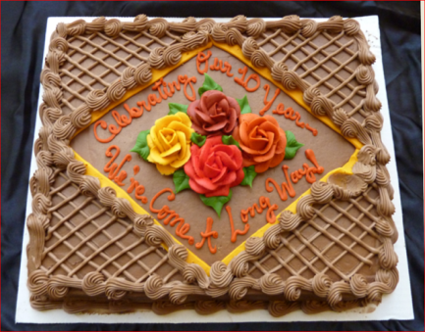
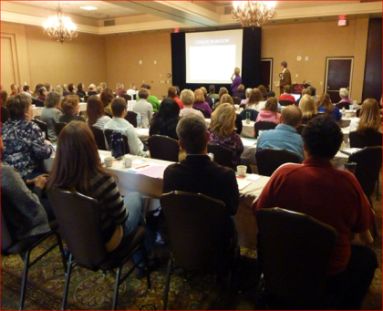

We wrapped up the conference with the awarding of the annual DARS/u.select Recognition Awards. The two recipients were Donna Marzolf, South Central College, for her eCatalog Creation work, and Daryl Johnson, Metropolitan State University, for his trickery while at the conference.

Conference evaluations again confirm gratitude for the opportunity to gather as a group and hear about/discuss topics related to the work we do and how we can better serve our students.

Presentations are posted on the MnSCU DARS/u.select project website at: http://www.dars.mntransfer.org/registration/agenda_October_2012.html

