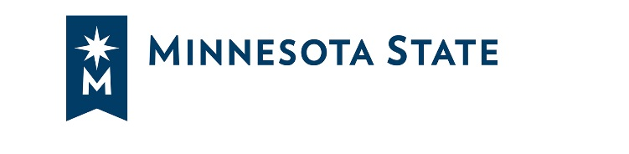
Spring 2018 Book Group & D2L Brightspace Course
A Professional Development Opportunity for All Faculty and Staff

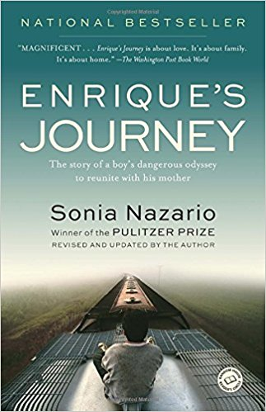
What: Statewide opportunity to read, discuss, interact, share and learn with a book on a topic of interest and relevance for our work. The topic is immigration and learning about our immigrant students and communities. Created by: Rebecca March and Cheryl Neudauer, Minneapolis Community and Technical College

The book is Enrique’s Journey: The Story of a Boy's Dangerous Odyssey to Reunite with His Mother. This is a true story from award-winning journalist Sonia Nazario recounting the odyssey of a Honduran boy who braves hardship and peril to reach his mother in the United States. https://www.goodreads.com/book/show/158277.Enrique_s_Journey

Who: All faculty and staff from any Minnesota State college or university are invited to participate. We also encourage campuses to:
- have conversations/meetings on your campus to complement our work together
- use a buddy system to move through any of the book group activities with a colleague
- purchase copies of books for employees on your campus (for example, through the library, center for teaching and learning, diversity office, etc.)

When: Between February-April 2018

How: This professional development opportunity has two main parts:
- Three 90-minute virtual Adobe Connect meetings to discuss how the experiences and perspectives in this book relate to our students and communities.
  - Thursday, Feb 22, 12:00-1:30 pm
  - Thursday, March 22, 12:00-1:30 pm
  - Thursday, April 26, 12:00-1:30 pm
- D2L Brightspace course to explore issues related to immigration, helping immigrant students succeed, and understanding our communities and the news. The “course” will use short, asynchronous, interactive activities to help us explore how we can better serve our students, connect across the system, and share resources.

Participate in as much or as little as you’d like or your schedules allow! For example, you could 1) complete some or all of the D2L Brightspace activities and not join the online meetings, 2) attend some or all of the online meetings and not participate in the D2L Brightspace course, 3) join us even if you have not read the book to learn with colleagues!

Contact:
Kimberly Johnson, Ph.D., Director for Faculty and Instructional Development
Email: kimberly.johnson@minnstate.edu

