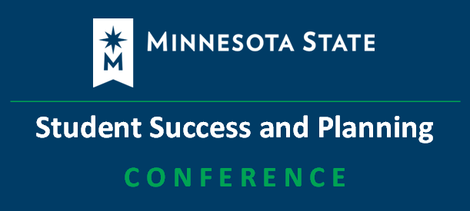
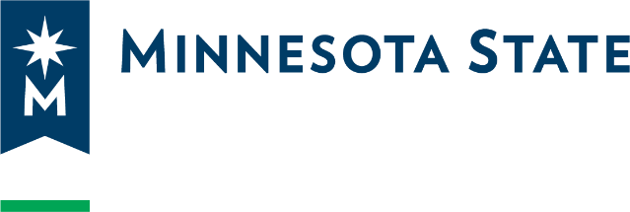2025 Minnesota State Student Success and Planning Conference

The agenda is subject to change. More detailed session information will be on the Conference Event Page.
Day 1: Wednesday, October 08, 2025, from 09:00 a.m. - 04:00 p.m.

09:00-09:15 Welcome: Paul Shepherd, Associate Vice Chancellor for Student Affairs and Enrollment Management, Minnesota State system office

09:15-09:50 Keynote: Staying Energized in Uncertain Times: Resilience Strategies for Higher Education. Mike Kutzke, Vice President of Student Success, Ridgewater College with an introduction by Kim Lynch, Associate Vice Chancellor for Educational Development and Technology, Minnesota State system office

09:50-10:00 Break

10:00-10:50 Large Group: Equity - What's Transfer Got to Do with It? Toward Making it All Make Sense. Cassandra Levesque, Mary Beth Lakin, Jessica Migler, Kelly Ponto Watrin, Minnesota State system office, Academic and Student Affairs

10:50-11:00 Break

11:00-11:50 Small Group 1: Breakout Sessions
- Empowering Campus-Wide Advising: The Student Success Advising Academy at Minnesota State University, Mankato
- What Did They Do? Managing Inherited uAchieve Encoding
- Our Transfer Portal - Creating Preliminary Transfer Reports for Prospective Students in Transferology
- Supporting Internationally Trained Professionals – PANEL
- Autism, ADHD, Anxiety, and More! Tools for Supporting Neurodivergent Students
- Tutor.com - Free Online Resource

11:50-01:00 Lunch Break

01:00-01:50 Large Group: Legal and Practical Considerations for Digital Accessibility. Melitta Drechsler, Assistant General Counsel, Office of General Counsel, Minnesota State system office; and Jody Ondich, Center for Faculty Innovation (CFI) Peer and Student Review Coordinator, Lake Superior College

01:50-2:00 Break

02:00-02:50 Small Group 2: Breakout Sessions
- Empowering Student Success: Unlocking Engagement with the Academic Advising D2L Brightspace Hub
- TES: Transfer Evaluation System - User Management Tips and Tricks
- What Do Students Read? Let’s Talk About Data-informed Library Collections Planning for Student Success
- Collecting Credit for Prior Learning (CPL) Data - What We Need to Know and How We Find Out
- Say Hi to AI: Artificial Intelligence (AI) Literacy Essentials for Student Success Professionals
- Designing for All: Universal Design for Learning (UDL) as a Path to Inclusive Learning

02:50-03:00 Break

03:00-03:50 Large Group 5: Town Hall / Ask Us Anything. This is an open forum discussion with your colleagues. Questions have been submitted for this discussion, but feel free to bring more! Facilitators: Conference committee members, Minnesota State system office
Day 2: Thursday, October 09, 2025, from 09:00 a.m. - 04:00 p.m.

09:00-09:50 Small Group 3: Breakout Sessions
- Transforming Student Experience: Implementing M State's Case Management Advising Model through Customer Relationship Management (CRM) Innovation
- Decoding Transferology: A Deep Dive into University of Minnesota Twin Cities (UMN-TC) Transfer Evaluations
- Fostering Campus Connections and Credit Mobility for Dual Enrollment Students
- The Credit for Prior Learning (CPL) Academy: For Faculty, By Faculty
- Shake It Off: Breaking Barriers for Veteran Students
- From Transfer to Credit: Empowering Evaluation with Power BI

09:50-10:00 Break

10:00-10:50 Large Group 6: NextGen Student Project Update. Brent Glass, NextGen Student Implementation Co-Lead; Kristina Keller, Rick Nahrgang, Kayla Westra, and Shanel Carter, NextGen Student Implementation Team, Minnesota State system office

10:50-11:00 Break

11:00-11:50 Small Group 4: Breakout Sessions
- Interwoven: Culture, Community, and Service
- Program and Transfer Encoding Tips and Tricks
- D2L Brightspace Accessibility Pilot: A Review
- Supporting Students with Sophia Learning
- ARE YOU READY FOR IT? Ready in 10 days: Preparing for a Veterans Affairs (VA) Compliance Survey Visit
- Someone in Your Corner: Enhancing Student Success with Mentoring Concepts

11:50-01:00 Lunch Break

01:00-01:50 Small Group 5: Breakout Sessions
- Transfer By Design
- Rewriting the Rules: From Few to Many Through the Implementation of TES: Transfer Evaluation System
- Cross-Institutional Collaboration to Better Serve Minneapolis College Students
- Enhancing Student Success in Credit for Prior Learning with MyCPL Technology
- Begin Again- Transforming Joint Services Transcript (JST) Credit Practices

01:50-02:00 Break

02:00-02:45 Large Group 7: NextGen Workday Student: A Sneak Peek Through the Advising Lens. Darcie Anderson, Winona State University and Merry Schmitt, Minneapolis College, NextGen Advising Functional Co-Coordinators, Minnesota State system office

02:45-02:55 Break

02:55-03:45 Large Group 8: What’s Happening with the Systemwide Customer Relationship Management (CRM) Request for Proposals (RFP)? Stephen Kelly, NextGen Student Companion Project and Generative AI Lead; and Ali Pickens-Opoku, System Director for Strategic Enrollment Management, Minnesota State system office

03:45-04:00 Large Group 9: Closing Remarks. Jesse Mason, Associate Vice Chancellor for Academic Affairs, Minnesota State system office

